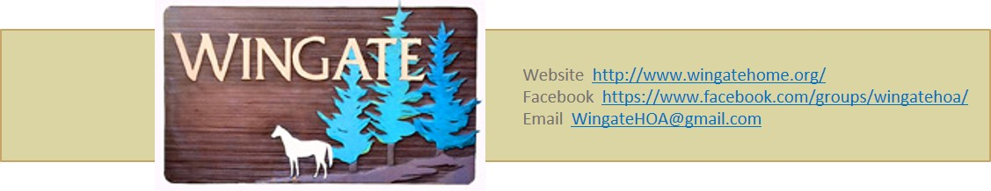October 27, 2021

Dear Wingate Homeowners and Residents:

The Wingate HOA Board of Directors wants to enhance transparency and understanding by explaining how our voluntary Board operates, especially in matters related to complaints and enforcement of the Wingate Covenants.

The Wingate HOA Board consists of Wingate residents who volunteered to be on the Board. No Board member is paid. The Board meets once a month from September through June. The primary functions of the Board are to maintain the livability of our Wingate neighborhood; to be good stewards of the HOA funds; to serve as the Architectural Control Committee and review change requests from residents (like cutting down a large tree, erecting a fence, or constructing an addition to a house or garage); to advise residents on Wingate Covenants; to provide platforms for communication (i.e., facebook, emails, and the wingatehome.org website); and to help mediate complaints received from Wingate residents.

An issue that needs clarification and transparency is the role of the Board in addressing complaints, including allegations that a certain Wingate Covenant is being violated. Please know that the Board members do not proactively patrol and police the Wingate neighborhood in search of violations of the Covenants prepared in the 1970s, portions of which are now considered quite outdated. Rather, the Board actively encourages neighbors to talk to each other about issues or concerns to help build an understanding among neighbors about those issues/concerns. If such an understanding cannot be reached, the Board will seek to help mediate any impasses.

Complaints about temporary structures and vehicles (e.g., storage tents, RVs, boats, etc.) on Wingate properties have been brought to the attention of the Board. The size, appearance, and use of such temporary structures/vehicles varies greatly, and many long-time Wingate residents know that although these temporary structures are forbidden by the Covenants, some have been present for years. Because the Board does not actively patrol and police the neighborhood for violations of the Covenants, including the status of temporary structures, residents are encouraged to talk with neighbors if they have concerns about certain structures/vehicles. A conversation is the first step in hopes of creating understanding and finding a mutually acceptable outcome. If a mutually acceptable outcome cannot be reached after a neighborly discussion, the Board can help mediate by assisting with interpretation of the Covenants and helping to convey concerns. But please know that the Board does not have the legal means or authority to force an outcome (i.e., put a lien on a house), and rather would defer initiation of legal action to the complainant. Of course, this situation should be avoided if Wingate is to maintain its neighborly essence.

Please know that this is not a new position for the Board, and precedent has been demonstrated in several cases. Neighborly discussions have led to compromise and resolution of minor Covenant infractions, (e.g., activity considered an annoyance or nuisance to the neighborhood, construction of a property fence without retaining an easement, etc.). The Board asks that residents educate themselves on the various provisions of the Wingate Covenants and encourage dialog with neighbors regarding any significant issues or concerns that may arise.

If you have more questions or are interested in joining the Wingate HOA Board of Directors and volunteering your time to help, please contact the Board at [wingatehoa@gmail.com](mailto:wingatehoa@gmail.com).

On behalf of your Wingate Board of Directors,

|  |  |  |  |
| --- | --- | --- | --- |
| **Frank Koegler-President**  (425) 412-3996  [frank-koegler@comcast.net](mailto:frank-koegler@comcast.net) | **Steve Altabef-Vice President**  (425) 745-4703  [sumcoun@aol.com](mailto:sumcoun@aol.com) | **Dave Pischer-Treasurer**  (206) 550-5426  [davepischer@comcast.net](mailto:davepischer@comcast.net) | **Debbie Fagala-Secretary**  (425) 771-5216  [seattledogk9@gmail.com](mailto:seattledogk9@gmail.com) |
| **Teresa Tilton**  (360) 298-6737  [ttilton9@gmail.com](mailto:ttilton9@gmail.com) | **Oscar Lopez**  (425) 745-3434  [oscarlopez77@comcast.net](mailto:oscarlopez77@comcast.net) | **Open Position** |  |